ACTIVITY 2
Choose one of the couch-surfer confessions as a basis to write a short story (250-300 words) about a hypothetical couch surfing experience.
Confession 1  “There’s no room for pride when you are couch surfing. There’s only room for humility, gratefulness, and a few changes of clothes.”  http://www.caitlinmuir.com/confessions-of-a-couch-surfer-part-one | 
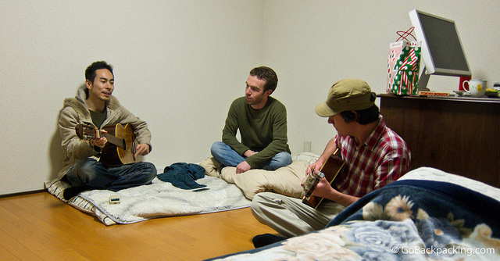 | Confession 2  “Be open. Open to new experiences, new types of people, and more. I can truly say it's changed my life, the way I travel, the way I learn about a country. If all you want is a free bed, don't bother.”  http://www.budgettravel.com/blog/confessions-of-a-couchsurfer,12936
Confession 3  “Couches are always different, and almost always, a pleasant surprise. Mine have ranged from sleeping on the floor cuddled up with a cat or a dog, to having my very own bedroom complete with king-sized bed, silk sheets, and marble ensuite.”  http://matadornetwork.com/abroad/confessions-of-a-serial-couchsurfer | 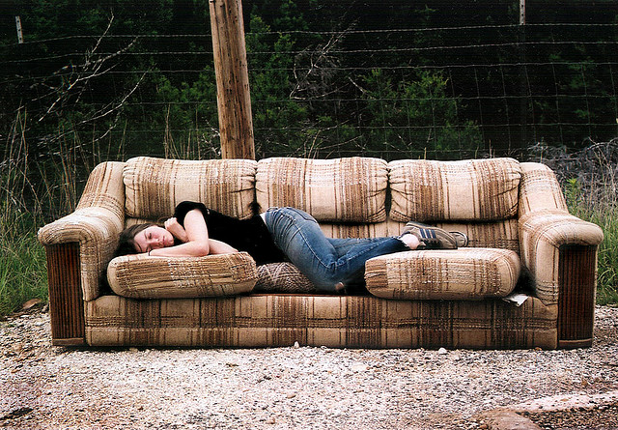
 | Confession 4  I've stayed with people in their 70s who just have extra rooms in their house. They always have great stories—I've stayed with scientists, philosophers, and anthropologists—soccer moms, recently-divorced women…you'd be surprised, but they're not all just college-aged kids in their 20s.  http://www.cosmopolitan.com/advice/tips/couch-surfing
Confession 5  “As a solo female traveler, I’ve always been a bit wary of Couchsurfing. I noticed that many of the hosts are young, single males— I was inundated by invitations for drinks, dancing, conversation by guys in whatever city I was in.”  http://www.cestchristine.com/2010/11/confessions-of-a-first-time-couchsurfer | 

My couch surfing story

